Tender Application:LC0001/31

Property Description:

The land area is approximately 2.358 acres more or less with a flat contour, divided into three separate paddocks.

Location: Patu-Kukupa Street Manaia

Licence to Occupy Document:
This document includes the terms and conditions to which you will be bound.

Additional information

Outgoings

Rates
The rates on this property are $800 per annum, each year, for the entire licensed period. This will be invoiced separately and in addition to your annual rental amount. You should take this into account when preparing your tender.

Water
Metered water supply is provided for the land, and you will be invoiced directly.

Grazing Permit – Urban
This property is zoned residential. An urban grazing permit will be applicable.

FORM OF TENDER

LICENCE TO OCCUPY FOR GRAZING PURPOSES

PATU-KUKUPA STREET MANAIA

South Taranaki District Council
Private Bag 902
HAWERA 4640

OR VIA EMAIL: propertymanager@stdc.govt.nz

RE: Tender – Patu-Kukupa Street, Manaia

I ………………………………………………………………………………………………….
(Full Name in Block Letters)

of …………………………………………………………………………………………………
(Full Postal Address)

…………….…………………………….. Telephone (Private): ……………………..
(Occupation)

Telephone (Business): ……………………..

Email: …………………………………………………………….

I hereby submit the following tender, in accordance with the terms and conditions of tender closing 2 November 2026.

I wish to tender the amount of $ ……………………………. (plus GST), being the annual rental for a Licence to Occupy for Grazing Purposes, Property Number 15671, Patu-Kukupa Street, Manaia containing approximately 2.358 acres more or less of Part Section 4-8, 14-17, and Part Section 23 Block V Town of Manaia as delineated in orange on the attached plan.
.

……………………………….…………… ……………………………….……
Signature Date

TERMS AND CONDITIONS OF TENDER

LICENCE TO OCCUPY FOR GRAZING PURPOSES

PATU-KUKUPA STREET, MANAIA

- All tenders must be submitted on the attached tender form and enclosed in a sealed envelope marked – TENDER – PATU-KUKUPA STREET, MANAIA. Alternatively, you can email the attached tender form to propertymanager@stdc.govt.nz.

- The tender must be received by email or the South Taranaki District Council, Private Bag 902, Hawera by 12pm. Monday 2 November 2026.

- The tender may be accepted by delivering a notice of acceptance to the tenderer, or by posting of such notice to the tenderer to the address set out on the form of tender signed by that person.

- The Council does not warrant the accuracy of any matter or fact herein or in the particulars and the tenderers must verify the same to the own satisfaction and enter into the contract reliant solely on their own judgment.

- Prospective tenderers should, before submitting a tender, ensure that their proposed use of the site will comply with Council’s requirements and bylaws.

- The area and legal description of the said land are believed to be correct and no error or misdescription which may exist herein shall annul the tender nor shall it be withdrawn nor shall any compensation be allowed to the tenderer by reason of any error or admission or misdescription (if any) in these terms and conditions of tender.

NOTE:

- The Chief Executive, South Taranaki District Council, shall not be bound, nor makes any undertaking to accept the highest or any tender.

- All tenders shall be deemed to have inspected the property and to have knowledge of the state and condition of the property including the buildings and improvements therein (if any) and to have satisfied themselves that it is suitable for the purposes for which they intend to use it. The Council shall accept no obligations or regulations in respect thereof, but the successful tenderer shall take the property as it is. Inspection may be arranged if required, by telephoning the Assets and Property Officer on 0800 111 323 during business hours.

- Any further information required may be obtained by telephoning the Property Officer – Legal on 0800 111 323 during business hours or by emailing: propertymanager@stdc.govt.nz

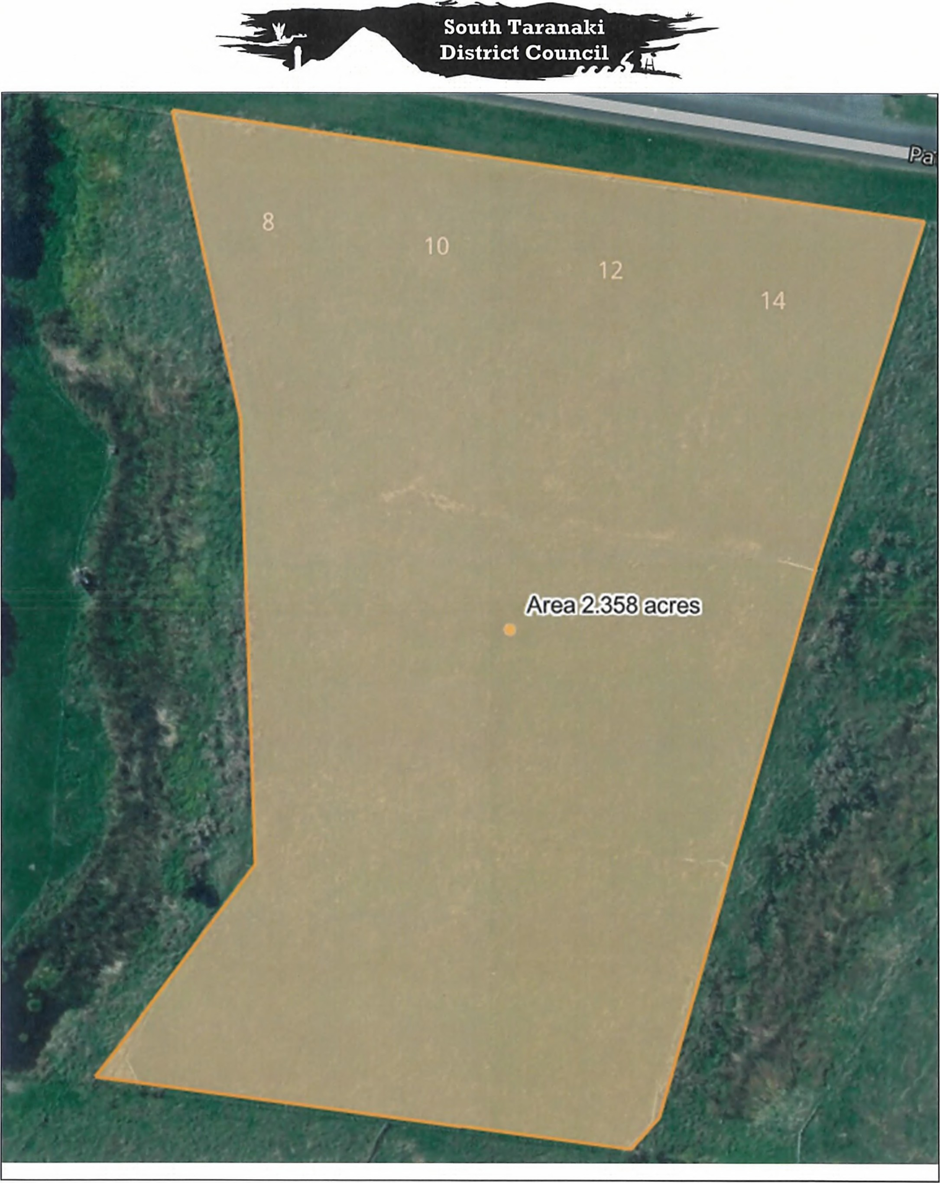

Scale: 1 841 Original Sheet Size A4 Printed: Printed By

LICENCE TO OCCUPY FOR GRAZING PURPOSES ON COUNCIL OWNED LAND

This Licence dated the _____________ day of _____________ 2026

Parties:
- South Taranaki District Council a body corporate constituted under the Local Government Act 2002 (“the Council”)

- ___________________ (“the Licensee”) of _______________, _____ (who with his/her Executors, Administrators and Assigns) is hereafter named (“the Licensee”).

Background:

- The Council owns the Land in fee simple and is empowered to grant a licence to occupy it pursuant to the Local Government Act 2002.

- The parties agree that the Council will grant a licence to occupy the Land on the terms set out in this Licence, including the Schedule.

General Provisions
- Interpretation:
In this Licence unless the context indicates otherwise:
  - Definitions: Any terms defined in Schedule One have the meaning that they are given in Schedule One, and

“GST” means tax levied under the Goods and Services Tax Act 1985 and includes any tax levied in substitution for that tax;
“Health and Safety at Work Act” means the Health and Safety at Work Act 2015, including any applicable regulations;
“Outgoings” means the outgoings specified in clause 4;
  - Defined Words and Expressions: words and expressions defined in this Licence have the defined meaning in the whole of this Licence, including the Background, and other parts of speech and grammatical forms of those words or expressions have corresponding meanings;
  - Sections, Clauses and Schedules: references to sections, clauses and schedules are references to sections, clauses and schedules in this Licence;
  - Headings: section, clause and other headings are for ease of reference only and do not form any part of the context or affect this Licence’s interpretation;
  - Plural, Singular and Gender: the singular includes the plural and vice versa, and words importing one gender will include the other genders;
  - Parties: references to parties are references to parties to this Licence;
  - Persons: references to persons include references to bodies of persons, whether incorporated or unincorporated, and any governmental or other regulatory bodies or authorities whether or not having separate legal personality;
  - Negative Obligations: any obligation not to do anything includes an obligation not to suffer, permit or cause that thing to be done; and
  - Statutes and Regulations: references to any statutory provision will include any statutory provision which amends or replaces it, and any subordinate legislation made under it.
- Term
  - The Term will commence on the Commencement Date and will end at 5.00pm on the Expiry Date set out in Schedule One, unless terminated sooner in accordance with this Licence.
  - For the avoidance of doubt, on the termination of this Licence, the Council is not obliged to grant the Licensee a further term or a further licence.
  - If the Licensee, with the consent of the Council, remains in occupation of the Land after the end of the Term, the Licensee will do so under a monthly licence determinable by either party by one month’s notice in writing given, at any time, to the other and will otherwise be on the terms contained in this Licence, including payment of the Licence Fee at the rate payable at the expiry of the Term.
- Rent
  - The Licensee will fully and punctually pay the Rent in advance by equal quarterly instalments on the Rent Payment Dates without any deduction whatsoever, upon receipt of Tax Invoice produced by the Council.
- Outgoings
All rates and other outgoings or charges which may be assessed, levied or payable in respect of their occupation of the Land will be paid by the Licensee on or before the respective due date.
- Use of The Land
The Licensee shall use the Land solely for the purposes of grazing, unless otherwise agreed in writing, and will at all times manage the Land diligently and in good husbandlike manner without in any way committing waste or diminishing the productivity of the Land.
- Maintenance
  - The Licensee will at all times during the term:
    - Keep in good order, repair, and condition, all fences (boundary and internal), gates, and other structures and improvements, including all of the Council’s water supply pipes, troughs, and fittings in or on the Land fair wear and tear excepted;
    - Maintain any grass and vegetation on the Land to good order;
    - Keep all live fences and hedges cut and trimmed; and in particular the Licensee will in alternate years during the Term, and during the months of May, June and/or July, in a proper and workmanlike manner, cut the sides and top all boxthorn and other live hedges on the Land or upon the boundaries thereof down to a reasonable height and width and will immediately after every cutting and topping clean up and dispose of the material cut from the said hedges in an appropriate manner;
    - Keep and maintain all drains, ditches, and water courses open, clean and clear of weeds;
    - Keep the Land clear from all gorse, broom, thistle and all noxious weeds and plant pests, rabbits, and vermin and in particularly duly and fully comply with the provisions of the Biosecurity Act 1993 and any notices or demands lawfully made or given under that Act. Plant pests are as advised by Taranaki Regional Council from time to time;
    - Adhere to the Council’s Vegetation Standard in respect of any berm adjoining the Land, which requires:
  - The berm to be maintained in a tidy state. The berm is the area between the roadway sealed edgeline to the boundary of the Land for the length of the property.
  - That the berm is to be kept free of all plant pests within the road reserve to the property boundary. Plant pests are as advised by the Taranaki Regional Council from time to time.
  - All hedges shall be maintained at least two metres clear of the road.
  - Berms be kept free of excess roadside vegetation. This includes a minimum of 500mm width around any roadside signs, marker pegs, and drainage channel inverts.
  - Vegetation height is not to exceed 300mm on the berm.
  - Any stormwater drainage ditches to be maintained and kept clear of excess vegetation to maintain a clear drainage path for storm water runoff.
    - Regularly ensure that all rubbish and garbage is removed from the Land;
    - Keep any rubbish bins or containers in a tidy condition;
    - Promptly notify the Council if any rubbish or refuse has been dumped on the Land, or if any person has undertaken any unauthorised activity that has damaged, or may damage, the Land (provided always that the Council may at its sole discretion determine whether or not to remove any such rubbish or refuse);
    - Ensure that full and proper precautions are taken to safeguard the Land against fire caused by the Licensee’s activities on the Land.
- Health and Safety:
  - The Licensee will comply with the requirements of the Health and Safety at Work Act and will notify the Council immediately if it becomes aware of any hazards on, or in the vicinity of, the Land.
  - The Licensee will ensure it observes all Council safety procedures applicable to the Land of which it is made aware. It will also provide and adopt its own health and safety systems and practices on the Land, such health and safety systems and practices to be acceptable to the Council in all respects.
- Comply with all Acts, Bylaws etc:
  - The Licensee will, at all times:
    - comply with all statutes, by-laws, regulations, rules and requisitions and district and regional plan rules (together “Rules”);
    - use its best endeavours to ensure that any members, invitees, employees and other occupants within its control who are using the Land comply with such Rules; and
    - Obtain and maintain all permits and consents necessary in respect of the Licensee’s use of the Land (such use being recorded in clause 5).
- Animal Welfare
  - The Council reserves the right to request the immediate removal from the Land any animal that appears to be in poor unhealthy or distressed condition and the Licensee shall comply with any such request. The Licensee shall adopt the highest standards of husbandry, care and handling of animals and to equal or exceed the minimum standards outlined in the appropriate code of welfare in order to meet their obligations under the Animal Welfare Act 1999. If at any time the Council is of the opinion these minimum standards are not being met the Council may terminate this licence on giving the Licensee one month’s notice in writing.
  - The Council, its agents and/or the SPCA may enter the Land immediately and without notice in response to concerns about animal welfare.
- Non-Permitted Actions
  - The Licensee will not at any time during the term:
    - Graze, or permit to be grazed on the Land, any bull or bulls or any other animal or animals likely to be dangerous to any person entering upon the Land;
    - Graze, or permit to be grazed on the Land, any pig;
    - Cultivate or crop the Land under any circumstances;
    - Erect, or place any improvements on the Land without the prior approval in writing of the Council. See Clause 19.5 if applicable.
    - Damage or destroy any natural, scenic, historic, cultural, archaeological, biological, geological, or other scientific features, or indigenous flora and fauna on the Land;
    - Cut down or damage, or permit to be cut down or damaged, any trees growing upon the said Land without first obtaining consent in writing of the Council.
- Failure to Comply
If the Licensee fails to comply with any of the covenants of this Licence the Council may do anything required to remedy that failure and charge the Licensee the reasonable cost of the work.
- Rights of Entry
  - The Licensee will permit the Council or any person authorised by the Council, to enter upon the Land at all reasonable times for the purpose of inspecting the state of the Land and for other reasonable purposes which may include, but shall not be limited to, access to operational sites and access to the Land for investigative works or other due diligence requirements.
  - The Council must give 48 hours’ notice to the Licensee before entering the Land.
  - Notice can be provided verbally, short message service (SMS), and in writing, including email.
  - In the event of an emergency, the Council or any person authorised by the Council may enter onto the Land without providing notification to the Licensee.
- Assignment
The Licensee shall not during the said term assign, sublet, or otherwise part with the possession of the Land or part thereof.
- Indemnity and liability
  - The Licensee indemnifies the Council and keeps the Council indemnified against all and any claims suits actions or other proceedings that may be brought against the Council because of any breach or non-observance of any of the covenants the Licensee is required to perform in this Licence.
  - The Licensee will repair any damage it causes to the Land, within seven days of receiving notice to repair from the Council. All repairs must be to the satisfaction of the Council. If the Licensee fails to make repair, the Council may do so at the Licensee’s expense.
  - The Council is not liable for any damage occurring to the Licensee’s property arising from theft, fire, vandalism, natural causes or otherwise.
- Minerals
The Licensee will have no right to any mineral (including metals, sand and limestone) on or under the Land and shall not work or open any quarry or use any mineral.
- Mutual Covenants
  - The Council and the Licensee agree:
    - The Council has the right at any time to take possession of any part of the Land, for use in connection with public works or for purpose of effecting improvements, with three (3) months’ notice.
    - If the Council takes possession of any part of the Land under clause 17.1.1, the Rent shall be reviewed by agreement between the Council and the Licensee to such proportionate sum that reflects the Land area then available to the Licensee.
    - If the whole of Land is required for any public work, or in the event of sale or transfer of ownership of the land, the Council may terminate this Licence with six (6) weeks’ notice in writing.
    - Council may, in an emergency, take possession of land without making any demand or giving any notice.
    - The Licensee acknowledges that this Licence is entered into by the Council as landowner and not as a regulatory authority. The two roles are different, and any consent or approval given by the Council in its capacity under this Licence will not be deemed to waive the requirement for or imply that the Council has granted consent or approval in its capacity as regulatory authority.
    - The Licensee acknowledges that the Licensee is entering into this Licence of its own accord and that the Council does not warrant that the Land is suitable for any purpose.
    - The Licensee will comply with all reasonable requests from the Council in respect of the Land.
- Reserves - not applicable
- Insurance
  - The Licensee must at all times during the Term keep in full force and effect a public liability insurance policy with an insurance company approved by the Council to cover the Council and the Licensee for any claims arising on or from the Licensee’s use of the Land. The amount of that cover must be no less than $1,000,000.00. The Licensee will, on request, provide the Council with a copy of the policy and evidence that the Licensee has paid the premium.
- Rights of Termination
  - The Licensee may give three months’ written notice to the Council at any time, for any reason, to terminate this Licence over the Land.
  - The Council may give three months’ written notice to the Licensee at any time, for any reason to terminate this Licence over the Land.
  - If the Rent hereby reserved or any part thereof shall be in arrears and unpaid for the space of thirty (30) days the Council may terminate this Licence upon giving the Licensee one months’ notice in writing.
  - In the event of a breach of any of the clauses contained herein, the Council may terminate this Licence upon giving the Licensee one months’ notice in writing.
  - Licensee’s Property on termination:
    - The Licensee must remove all the Licensee’s improvements, other personal property and stock (together the “Licensee’s Property”) from the Land no later than the Expiry Date, or earlier termination of this Licence, unless otherwise agreed, in writing.

    - If the Licensee fails to comply with clause 19.5.1, the Council may:
      - remove the Licensee’s Property and repair any damage to the Land, in which case the Licensee must pay to the Council, on demand, all costs incurred by the Council in doing so; or
      - elect to take ownership of the Licensee’s Property, by written notice to the Licensee, in which case the Licensee’s Property will become the Council’s property, without any compensation whatsoever being payable to the Licensee, at 5pm on the seventh day after the date of service of the notice on the Licensee; or
      - require the Licensee, by written notice, to remove the Licensee’s Property by 5pm on the seventh day after the date of service of the notice on the Licensee.
    - If the Licensee fails to pay the costs demanded under clause 19.5.2(a), the Council may sell any of the Licensee’s Property removed by the Council, in any manner the Council sees fit, to meet the Council’s costs of removal and apply the balance (if any) towards meeting the Council’s claims (if any) against the Licensee.

    - If the Licensee fails to comply with a notice under clause 19.5.2(c), the Licensee’s Property will immediately become the Council’s property, without any compensation whatsoever being payable to the Licensee.

    - The Licensee must repair any damage to the Land caused by the Licensee’s removal of the Licensee’s Property.

- General
  - Nothing in this Licence is to be construed as creating an employer/employee relationship, a partnership, a fiduciary relationship or a joint venture relationship between the Council and the Licensee.
  - No amendment to this Licence will be effective unless it is in writing and signed by both parties.
  - No waiver of any breach of this Licence may be deemed to be a waiver of any other or subsequent breach. Failure of either party to enforce any clause of this Licence at any time may not be interpreted as a waiver of that clause.
  - The Licensee must pay all GST, if any, on the Rent and other payments made by the Licensee under this Licence either to the Council or as the Council directs as well as any additional GST the Council may be required to pay as a resolute of the failure to pay when required.
  - If any dispute arises between the parties relating to this Licence, unless agreed otherwise, the parties will attempt to resolve the dispute by informal dispute resolution techniques for at least 21 days from the day that a party receives written notice of the dispute from the other party. This clause does not prevent the parties from otherwise exercising their rights under this Licence.
  - The Licensee shall pay all legal costs incidental to the preparation of this Licence and all legal costs incidental to the enforcement or attempted enforcement of the Council’s rights and powers under this Licence.
  - Any notice required or authorised to be delivered under this Licence may be delivered in any manner mentioned in Part 7 of the Property Law Act 2007 to the Council’s address, 105-111 Albion Street, Hawera 4610 or email: propertymanager@stdc.co.nz.

SIGNED on behalf of the
SOUTH TARANAKI DISTRICT COUNCIL by:

________________________________
Chief Executive - South Taranaki District Council

________________________________
Print name:

________________________________
Date

SIGNED by the
Licensee

________________________ _______________________________
Print name: Signature

________________________ _______________________________
Print name: Signature

________________________________
Date

Witnessed by:

________________________ _______________________________
Print name: Signature

________________________ _______________________________
Witness occupation: Witness address:

SCHEDULE ONE

The Land: 2.358 hectares more or less being Section 4-8, Section 14-17 and Part Section 23 Block V Town of Manaia, as outlined in orange on the attached plan.

Commencement Date: 4 November 2026

Term: Three (3) years

Expiry Date: 4 November 2029

Rent: $_______ plus GST per annum

Rent Payment Dates: TBA

Rates: Yes, $800 per annum, 1 July

Special Conditions:

Water Supply and Maintenance

A single water meter with backflow meter is provided to the Block.

- The lessee is responsible for the installation and maintenance of pipes from the meter to any troughs located on the block; and
- For ensuring that troughs and fittings are maintained of good working order and that leaks are promptly repaired.

Fencing

For clarity, the responsibilities for the maintenance of fences are:

Lessees Responsibilities
- The replacement and repair of damaged / broken posts and battens on boundary fences.
- The replacement and repair of damaged wire on boundary fences
- The repair and maintenance of gates where practical.
- All maintenance and replacement of internal fences.

Councils Responsibilities
- The replacement of rotten posts and battens on boundary fences
- The replacement of boundary gates that have no further useful life

The Council is not responsible for the maintenance or replacement of internal fences.

