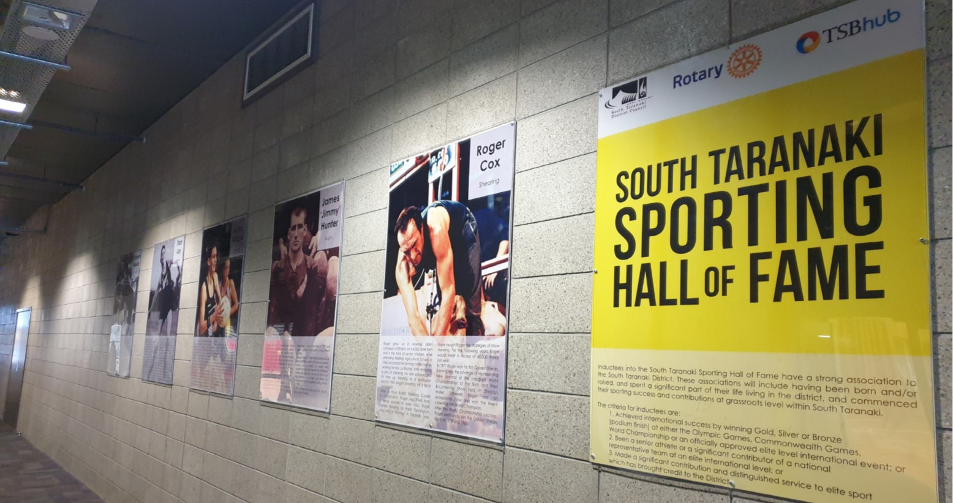



2024 Nomination Form



Background
During the design and construction of TSB Hub in Hāwera, a South Taranaki Sporting Hall of Fame was initiated and included. The purpose was to recognise those from South Taranaki who had made a significant contribution to sport.

In 2011, the Hāwera Rotary Club Inc. agreed to assist the Council with the project as champions to develop and support the establishment of the Sporting Hall of Fame, located on the ground floor at TSB Hub.

The objectives for the Hall of Fame are:
- To foster pride in the District;
- To enhance the image of our District to residents and visitors; and
- To acknowledge the achievements of sports people from the South Taranaki District.

The Sporting Hall of Fame committee is made up of two members of Hāwera Rotary Club, the South Taranaki Mayor, one Councillor and one independent member of the public. The committee meet following the close of applications and assess each nomination to select the inductees for each year.

Criteria
Inductees to the Sporting Hall of Fame will have a strong association to the South Taranaki District including:
- Having been born and/or raised and spent a significant period of their life living in South Taranaki; and
- Commenced their sporting success and contributions at grassroots level within South Taranaki.

Nominees for the Hall of Fame should have:
- Achieved international success by winning gold, silver or bronze at either the Olympic Games, Commonwealth Games, World Championship, or an officially approved elite level international event; or
- Were a senior athlete or a significant contributor of a national representative team at an elite international level; or
- Made a significant contribution and distinguished service to elite sport which has brought credit to the District.

It is preferred that nominees be retired from elite level sport for at least five years before being nominated for the Hall of Fame.

Nominations are considered annually by the committee convened for the purpose of inducting individuals to the South Taranaki Sporting Hall of Fame. Nominees to be inducted must have performed at an outstanding level, usually representing New Zealand at an elite international competition. Successful nominees or immediate family members of the nominee are expected to provide the committee with as much biographical and sporting background as possible. Inductees to the South Taranaki Sporting Hall of Fame will be recognised at a special function to celebrate their success. A display highlighting the athlete’s achievements is mounted in the hallway at TSB Hub in Hāwera. The South Taranaki Sporting Hall of Fame committee will have final say on all inductees and their decision will be final.
Nomination

Full Name . . . . . . . . . . . . . . . . . . . . . . . . . . . . . . . . . . . . . . . . . . . . . . . . . . . . . . . . . . . . . . . . . . . . . . . . . .
Sport . . . . . . . . . . . . . . . . . . . . . . . . . . . . . . . . . . . . . . . . . . . . . . . . . . . . . . . . . . . . . . . . . . . . . . . . . .
Address . . . . . . . . . . . . . . . . . . . . . . . . . . . . . . . . . . . . . . . . . . . . . . . . . . . . . . . . . . . . . . . . . . . . . . . . . .
Phone . . . . . . . . . . . . . . . . . . . . . . . . . . . . . . . . . . . . . . . . . . . . . . . . . . . . . . . . . . . . . . . . . . . . . . . . . .
Email . . . . . . . . . . . . . . . . . . . . . . . . . . . . . . . . . . . . . . . . . . . . . . . . . . . . . . . . . . . . . . . . . . . . . . . . . .
Date of Birth . . . . . . . . . . . . . . . . . . . . . . . . . . . Place of Birth . . . . . . . . . . . . . . . . . . . . . . . . . . . . . . .
If the nominee is deceased please give the date the nominee passed away . . . . . . . . . . . . . . . . . . . . . .

Summary of Nominee’s sporting achievements
. . . . . . . . . . . . . . . . . . . . . . . . . . . . . . . . . . . . . . . . . . . . . . . . . . . . . . . . . . . . . . . . . . . . . . . . . . . . . . . . . . . . . .
. . . . . . . . . . . . . . . . . . . . . . . . . . . . . . . . . . . . . . . . . . . . . . . . . . . . . . . . . . . . . . . . . . . . . . . . . . . . . . . . . . . . . .
. . . . . . . . . . . . . . . . . . . . . . . . . . . . . . . . . . . . . . . . . . . . . . . . . . . . . . . . . . . . . . . . . . . . . . . . . . . . . . . . . . . . . .
. . . . . . . . . . . . . . . . . . . . . . . . . . . . . . . . . . . . . . . . . . . . . . . . . . . . . . . . . . . . . . . . . . . . . . . . . . . . . . . . . . . . . .
. . . . . . . . . . . . . . . . . . . . . . . . . . . . . . . . . . . . . . . . . . . . . . . . . . . . . . . . . . . . . . . . . . . . . . . . . . . . . . . . . . . . . .
. . . . . . . . . . . . . . . . . . . . . . . . . . . . . . . . . . . . . . . . . . . . . . . . . . . . . . . . . . . . . . . . . . . . . . . . . . . . . . . . . . . . . .
. . . . . . . . . . . . . . . . . . . . . . . . . . . . . . . . . . . . . . . . . . . . . . . . . . . . . . . . . . . . . . . . . . . . . . . . . . . . . . . . . . . . . .
. . . . . . . . . . . . . . . . . . . . . . . . . . . . . . . . . . . . . . . . . . . . . . . . . . . . . . . . . . . . . . . . . . . . . . . . . . . . . . . . . . . . . .
. . . . . . . . . . . . . . . . . . . . . . . . . . . . . . . . . . . . . . . . . . . . . . . . . . . . . . . . . . . . . . . . . . . . . . . . . . . . . . . . . . . . . .
. . . . . . . . . . . . . . . . . . . . . . . . . . . . . . . . . . . . . . . . . . . . . . . . . . . . . . . . . . . . . . . . . . . . . . . . . . . . . . . . . . . . . .
. . . . . . . . . . . . . . . . . . . . . . . . . . . . . . . . . . . . . . . . . . . . . . . . . . . . . . . . . . . . . . . . . . . . . . . . . . . . . . . . . . . . . .
. . . . . . . . . . . . . . . . . . . . . . . . . . . . . . . . . . . . . . . . . . . . . . . . . . . . . . . . . . . . . . . . . . . . . . . . . . . . . . . . . . . . . .
. . . . . . . . . . . . . . . . . . . . . . . . . . . . . . . . . . . . . . . . . . . . . . . . . . . . . . . . . . . . . . . . . . . . . . . . . . . . . . . . . . . . . .
. . . . . . . . . . . . . . . . . . . . . . . . . . . . . . . . . . . . . . . . . . . . . . . . . . . . . . . . . . . . . . . . . . . . . . . . . . . . . . . . . . . . . .
Please attach additional paper or documentation if you need more space.
Nominator Details

Full Name . . . . . . . . . . . . . . . . . . . . . . . . . . . . . . . . . . . . . . . . . . . . . . . . . . . . . . . . . . . . . . . . . . . . . . . . . .
Club affiliation (if applicable) . . . . . . . . . . . . . . . . . . . . . . . . . . . . . . . . . . . . . . . . . . . . . . . . . . . . . . . . . .
Address . . . . . . . . . . . . . . . . . . . . . . . . . . . . . . . . . . . . . . . . . . . . . . . . . . . . . . . . . . . . . . . . . . . . . . . . . .
Phone . . . . . . . . . . . . . . . . . . . . . . . . . . . . . . . . . . . . . . . . . . . . . . . . . . . . . . . . . . . . . . . . . . . . . . . . . .
Email . . . . . . . . . . . . . . . . . . . . . . . . . . . . . . . . . . . . . . . . . . . . . . . . . . . . . . . . . . . . . . . . . . . . . . . . . .
Nominations can be sent to South Taranaki District Council
C/- Ella Tosland
Private Bag 902
Hāwera 4640

Alternatively, these can be emailed to ella.tosland@stdc.govt.nz, dropped into the South Taranaki District Council administration building on Albion Street, delivered to your local South Taranaki LibraryPlus or dropped into the TSB HUB

Nominations close Friday 1 November 2024

Inductees to the South Taranaki Sporting Hall of Fame
Name | Sport | Year Inducted
Roger Cox | Shearing | 2017
James ‘Jimmy’ Hunter | Rugby | 2017
Adine Wilson | Netball | 2017
Stan Lay | Athletics | 2018
Graham Mourie | Rugby | 2018
Michael Campbell | Golf | 2019
Graeme West | Rugby League | 2019

