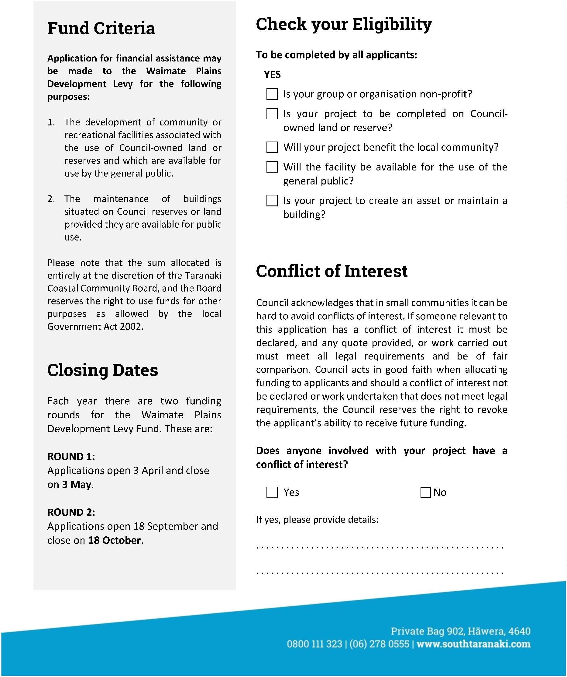




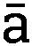
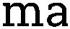













CLOSING DATES

Each year there are two funding rounds for the Waimate Plains Development Levy Fund in 2026. These are:

Round 1:
Applications open 10 April 2026 and close 8 May 2026

Round 2:
Applications open 28 August 2026 and close 5 October 2026

