Report
To | Mayor and Councillors
From | Regulatory Services Manager, Chantelle Denton
Date | 21 September 2020
Subject | Annual Dog Control Policy and Practices Report - 2019/20
(This report shall not be construed as policy until adopted by full Council)

Executive Summary

- The Council is required under the Dog Control Act 1996 (the Act) to provide a report for the financial year on the administration of the Dog Control Policy (the Policy) and dog control practices along with a range of statistical data. This report recommends the adoption of the Annual Dog Control Report which will allow it to be publicly notified as required by the Act.

Recommendation(s)

THAT the Council;

- Approves the South Taranaki District Council 2019/20 Annual Dog Control Report in accordance with Section 10A of the Dog Control Act 1996.

- Notes that approval will trigger public notification of the report and that a copy will be provided to the Secretary for Local Government.

Background

- Every year the Council is required, under the Act, to report on the administration of its Dog Control Policy and practices for the financial year. A recent legislative change requires the report to be published on the Council website. The Act is specific on the scope of the report and how it is publicised (see Legislative Considerations).

Local Government Purpose

- Under the Local Government Act 2002, the Council’s purpose is to “promote the social, economic, environmental and cultural well-being of communities in the present and for the future”. The purpose of the LGA 2002 Section 10 aligns with the considerations under section 10A of the Dog Control Act 1996.

Considerations and Assessments

- In terms of the Council’s Significance and Engagement Policy the decision to adopt and release the Annual Dog Control Report (the Report) is of low significance. In terms of engagement, it should be noted that the Section 10A of the Act requires public notification of the report following adoption and from 2019 the report must be published online.

Legislative Considerations

- Under Section 10A of the Act the Council must, in respect of each financial year, report on the administration of its Policy (as adopted under Section 10) and its Dog Control Practices. The Report is required to include the following for each financial year:

“(a) the number of registered dogs in the territorial authority district
(b) the number of probationary owners and disqualified owners in the territorial authority district
(c) the number of dogs in the territorial authority district classified dangerous under Section 31 and the relevant provision under which the classification is made
(d) the number of dogs in the territorial authority district classified as menacing under Section 33A or 33C and the relevant provision under which the classification is made
(e) the number of infringement notices issued by the territorial authority
(f) the number of dog related complaints received by the territorial authority in the previous year and the nature of those complaints; and
(g) the number of prosecutions taken by the territorial authority under this Act.”

- The Act is specific regarding the requirements for advertising the Report and that the report must be provided to the Government as specified below:

“3) The territorial authority must give public notice of the report -
(a) by means of a notice published in –
(i) One or more daily newspapers circulating in the territorial authority district; or
(ii) One or more other newspapers that have at least an equivalent circulation in that district to the daily newspapers circulating in that district; and
(b) by any means that the territorial authority thinks desirable in the circumstances.
4) The territorial authority must also, within one month after adopting the report, send a copy of it to the Secretary for Local Government.”

Financial/Budget Considerations

- There are no financial or budget considerations regarding this report.

Consistency with Plans/Policies/Community Outcomes

- Nothing in this report is inconsistent with any Council policy, plan or strategy.

- This matter contributes to our District’s community outcome namely:

- Together South Taranaki

Impact on Māori/Iwi

- Māori equally benefit from the enforcement of the Act, which provides a safe environment within the District. All dog owners and the greater public benefit from the regulation of dog ownership and education.

Affected Parties Consultation

- No formal consultation on the document is required, as it is reporting on the activities of the previous year. The Act requires that the public are notified of the Report via notification in a newspaper that is circulating in the District. It is standard practice that the Report is also available online on the Council’s website.

Conclusion

- This report seeks to obtain the approval of the attached Annual Dog Control Report which provides information on the administration and enforcement of the Act and Policy for the 2019/20 financial year.

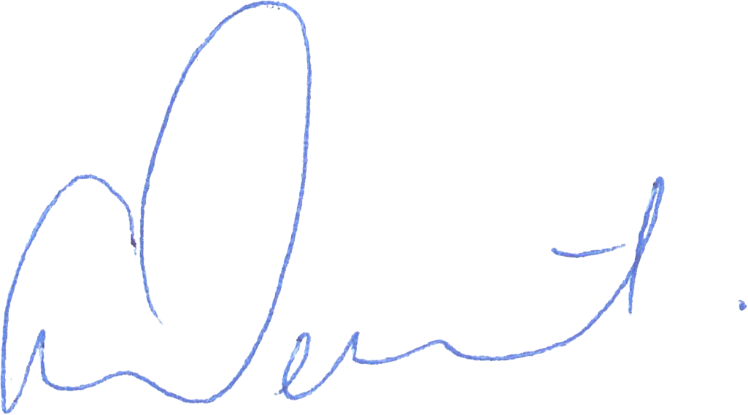

[Seen by]
Chantelle Denton Liam Dagg
Regulatory Services Manager Group Manager
Environmental Services

South Taranaki District Council
2019/20 Annual Dog Control Report

Dog Control Policy and Practices

- The Dog Control Act 1996

The Dog Control Act 1996 (the Act) requires territorial authorities to publicly report on Dog Control Policies and Practices as outlined under Section 10A. This report contains information and statistics on the South Taranaki District Council’s Dog Control activity for the year 1 July 2019 to 30 June 2020.

- Dog Control Policy and Bylaw

A comprehensive review was undertaken of the Council’s Dog Control Policy (the Policy) and Dog Control Bylaw (the Bylaw) in 2019. Within the Bylaw, new dog control areas were added and redundant areas were removed and new provisions came into effect and in force during this reporting round.

2.1 Dog Control Areas

Dogs must be on a leash at all times within the South Taranaki District’s public urban areas, with the exception of designated unleashed dog exercise areas. The Council has also designated prohibited dog areas. These provisions are the subject of the revised Dog Control Bylaw which took effect mid-November 2019.

- Administration

3.1 Personnel

Two Animal Management Officers, 1 Animal Management Cadet and an after-hours contractor, ensure 24 hours, seven days a week coverage of dog control activities.

3.2 Hours of Operations

Animal Management Officers work 8.00am to 4.30pm, five days a week and respond to all animal complaints. After-hours contractors are available from 4.30pm to 8.00am during weekdays and 24 hours a day on weekends and statutory holidays and respond to complaints other than roaming dogs and dog barking complaints which are referred to the Animal Management Officers to be actioned. Collectively, the Officers and Contractors provide the South Taranaki District with a 24-hour dog control service.

3.3 Dog Pound

The Council’s Dog Pound is open to the public from 1.00pm to 2.00pm Monday to Friday, excluding public holidays.

Within the Pound there are 21 kennels and two exercise areas. Of these, 16 are general kennels, three are used for puppies or isolation and two are for dangerous dogs. When dogs are impounded, owners have seven days in which to claim their dogs. Any dogs not claimed within seven days are either re-homed or euthanized. Each dog is assessed by Officers and the SPCA for suitability for re-homing.

4.0 Fees and Charges

The following table provides the fees and charges associated with running the Council’s Animal Control service for the 2019/20 year.

Charges | Fee for 2019/20 year  (GST inclusive)
Urban | $150.00
Urban (spayed/neutered) | $123.00
Selected Owner Policy (SOP) | $92.00
Selected Owner Policy (SOP) – Spayed/Neutered | $71.00
Rural – first two dogs (each) | $59.00
Rural – third and subsequent dogs (each) | $49.00
Seeing Eye Dog/ Hearing Dog | Free
Dangerous Dogs | Base fee + 50%
Dog impounding (1st) | $90.00
Dog impounding (2nd) | $135.00
Dog impounding (3rd) | $180.00
3+ Dog Permit | $75.00
Sustenance per day (payable on impound and every 24 hours thereafter) | $15.00
Destruction of Dog | $65.00
Dog Re-homing fee | $35.00
Microchipping (at the Pound) | $50.00
Microchipping (by arrangement) | $70.00

5.0 Dog Population Analysis

The chart below shows the different classes of dogs which make up the 4,634 registered dog population in the District.

6.0 Enforcement

6.1 Complaints

A total of 1,245 complaints were received during the 2019/20 year and is compared to previous years as follows:

Type of Complaint Received | 2016/17 | 2017/18 | 2018/19 | 2019/20
Dog Attack | 65 | 67 | 47 | 56
Rushing/Threatening | 32 | 49 | 46 | 26
Roaming | 563 | 615 | 623 | 570
Barking | 506 | 595 | 403 | 431
Welfare | 12 | 16 | 3 | 2
General Dog Complaints | 473 | 348 | 202 | 160
Total | 1,651 | 1,690 | 1,324 | 1,245

6.2 Impounding

A total of 189 dogs (203 in 2018/19) were impounded during the year of which 124 were either returned or re-homed, and 65 euthanized. The total dogs impounded decreased significantly over this period, this could be due to the active involvement and education in the community from the Animal Management Team. During Covid-19 lockdown a significant decline in dog activity was observed.

6.3 Classification of Dog Owners

The Council did not classify any dog owners as “disqualified from owning a dog” in the 2019/20 year. The South Taranaki District has a total of seven disqualified dog owners. There are currently no probationary owners in the District.

 | Total for 2019/20 | Total in District
Probationary Owner | 0 | 0
Disqualified Owner | 0 | 7

6.4 Classification of Dogs

Dogs can be classified in three different ways:

- Menacing classifications under Section 33A of the Act are applied to a dog which the Council considers may pose a threat to any person, stock, poultry, domestic animal or protected wildlife due to observed or reported behaviour; or any characteristic associated with the dog (their behaviour);
- Menacing classifications under Section 33C of the Act are applied to a dog which belongs wholly or predominantly to one or more breeds or types listed in Schedule 4 of the Act (their breed); or
- Dangerous dogs under Section 31 of the Act are applied to a dog if the owner is convicted under 57A(2), if there is evidence that the dog is aggressive or the owner admits that the dog is aggressive.

Under the Council’s Policy, all dogs classified as menacing are required to be de-sexed and to be muzzled in public.

 | Total for 2019/20 | Total in District
Menacing classification under section 33A – by behaviour | 4 | 34
Menacing classification under section 33C – by breed | 17 | 114
Dangerous classification under section 31 | 0 | 1

6.5 Infringements

A total of 379 infringement notices were issued for the following offences:

Infringement Offences | 2016/17 | 2017/18 | 2018/19 | 2019/20
Failure to provide care and attention | 0 | 0 | 0 | 0
Failure to register a dog | 348 | 305 | 311 | 366
Falsely notifying of death of dog | 0 | 0 | 0 | 0
Failure to comply with class as menacing dog | 1 | 0 | 0 | 0
Wilfully obstructed dog control officer or ranger | 1 | 4 | 0 | 0
Provided false particulars relating to dog owner | 0 | 0 | 0 | 0
Owner failed or refused to supply information relating to their dog | 1 | 0 | 0 | 0
Had possession of a counterfeited dog registration label or disc | 0 | 0 | 0 | 0
Failed to keep dog controlled or confined | 44 | 49 | 38 | 12
Failed to keep dog under control | 14 | 2 | 3 | 1
Owner failed to carry or use leash in public place | 0 | 0 | 0 | 0
Failed to muzzle dog classified as menacing | 3 | 0 | 0 | 0
Failed to neuter dog classified as menacing | 0 | 0 | 0 | 0
Owner failed to have dog implanted with microchip transponder | 106 | 102 | 119 | 0
TOTAL | 518 | 462 | 471 | 379

6.6 Court Proceedings

There were no prosecutions undertaken for offences under the Act, for the 2019/20 year.

- Other Services

7.1 Multiple Dog Permits (3+ Permit)

A permit is required to keep more than two dogs in an urban area and the decision to issue this permit is based on the suitability of the owner, their property and a survey carried out with potentially affected neighbours. A total of 9 permits were issued for the 2019/20 year.

7.2 Selected Owner Policy (SOP) Status

SOP status provides a discounted rate on dog registration as an incentive to good dog owners, who meet the specified criteria under the Policy. The requirements to meet SOP status is that the dog/s are well cared for (this includes feeding, housing, exercise and a secure section) and have a current vaccination certificate. The owner must be present during the inspection. If the person owns a menacing or dangerous dog, they cannot apply for SOP status.

An owner must have resided in the District and have owned the dog for 12 months and have no history of dog control issues. Owners transferring into the District can apply if they have held SOP status in their previous district, with no reported dog control issues for the previous 12 months.

 | 2018/19 | 2019/20
Dogs on Selected Owner Policy | 922 | 917

